Isabel Forward

American Literature

13 March 2020

Lesson Five:

*The Great Gatsby* Chapter 4

Context

I designed this lesson for the three sections of American Literature: College Prep (CP) American Literature 01, CP American Literature 02, and AP Language and Composition. Each section has a vastly different class culture, comprehension of the text, and level of analysis in class. For this reason, I made adjustments from class to class and slightly altered the learning objectives accordingly.

While you were originally going to observe the American Literature 02 class—a small class that participates often, but occasionally gets off-track—I taught the lesson the day before to the larger and quieter American Literature 01 class. The specifics of the procedures of this lesson are catered towards the American Literature 01 class that I did teach so that I have the opportunity to reflect.

Over the past several weeks, students have been reading and discussing *The Great Gatsby*, paying special attention to their assigned literary lens at the beginning of the unit. Students from the College Prep class were assigned the following themes:

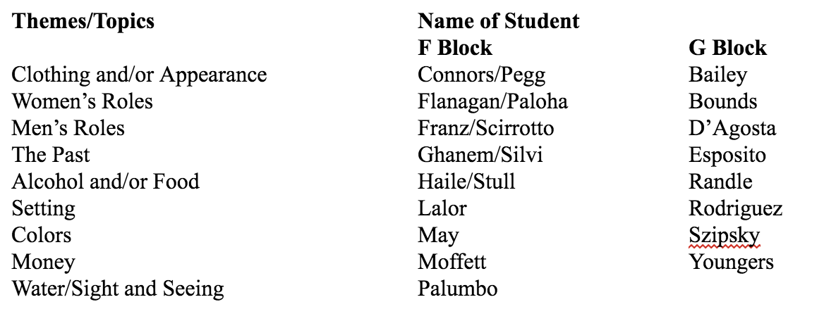

Students from the AP Language class were assigned the following literary theories:

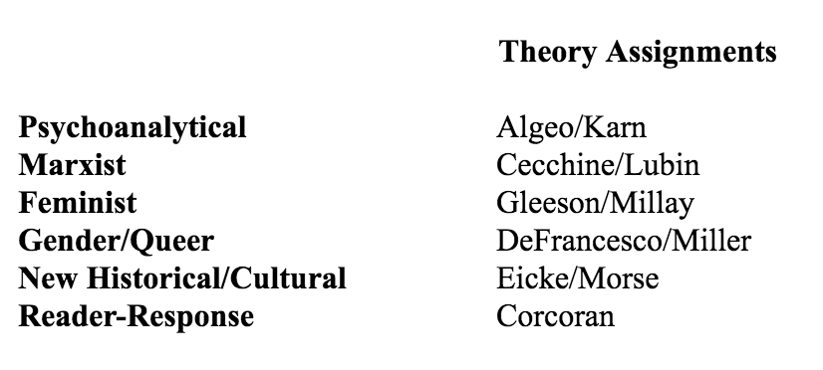

At night, students read *Gatsby* while taking note of specific instances of their theme/theory in the text. Students then begin class by writing a one paragraph response answering the following questions: Where did my theme appear in last night’s reading? How does this contribute to my greater understanding of the text? Students are graded out of ten points for each of these responses. At the end of the unit, students write an essay on their theme/lens throughout the work.

The students have been enjoying reading *The Great Gatsby*, but the different sections present different challenges. The students in AP Language are typically hesitant to participate, but offer complex and sophisticated analysis and demonstrate a high level of comprehension of the text and its subtleties. The eight students in CP American Literature 02 sometimes struggle with comprehension of the text, but participate often and ask meaningful questions that bring us to a higher level of analysis. The 16 students in CP American Literature 01 range greatly in their comprehension of the text, but often require a breakdown of the previous night’s reading.

Chapter 4 of *The Great Gatsby* includes many dialogue-heavy scenes and introduces several new characters. For this reason, in this lesson, students will break up into groups and act out the dialogue of different scenes.

I created this lesson with all three sections in mind: For AP Language, the students have expressed how they love acting. In their performances of the scenes, we spent time discussing the performative nature of Gatsby’s existence and how the dialogue standing alone differs greatly from Nick’s analysis and reading of the situation. The students had the ability to give characters different intonations in their voices to emphasize their different personalities and intentions.

For CP American Literature, breaking up the different scenes would help students comprehend what happened in the chapter from scene to scene, distinguish the many different characters who were introduced, and gain a greater understanding of why so many of the conversations were significant. For Section 01, students who hesitate to participate get their voices heard in a small group setting.

The previous class (**3/11**), students were assigned the following tasks:

* Read *The Great Gatsby*, Chapter 4, paying special attention to your assigned theme/literary theory.

The following class (**3/16**), students will be assigned the following tasks:

* Read *The Great Gatsby*, Chapter 5, paying special attention to your assigned theme/literary theory.
* Revise short story tests.

Materials

*The Great Gatsby* — Chapter 4

Reading response sheets — Half sheets of paper with the following questions: Where did my theme appear in last night’s reading? How does this contribute to my greater understanding of the text?

Lesson Objectives

By the end of the lesson, students will be able to…

* Identify the new characters in Chapter Four and their significance in the greater context of the novel
* Read text through the lens of different literary themes/theories
* Comprehend the role of contrasting roles of dialogue and description in characterization

Evidence

**Reading Response** (See “Context”)

**Daily Temperature Check** (See “Procedures”)

**Scene Skits and Explanation** (See “Procedures”)

**Class Discussion**

Procedures

**Housekeeping**

Pass back reading responses

Announce short story test revisions due Monday

**Reading Response** — 10 minutes

**Daily Temperature Check** (Whole Class)

What from the reading last night stuck out to you?

What from the reading are you still trying to understand?

**Scene Skits**

*As a class, review the concept of Gatsby as a performer.*

* Nick calls Gatsby a “character.” In what ways is Gatsby’s existence a performance?
* How does what Gatsby says differ from reality?
* Recall the disappearing act from the first scene. Review concept of Gatsby as a magician.
* Nick is “attracted and repulsed” by Gatsby. We begin to see Gatsby as two people: The character he performs and the person who loves Daisy (the person who has no purpose vs. the person with the ultimate purpose of love).

*Split students into pre-assigned groups.* In American Literature 01, I assigned the groups to each include students with a greater comprehension of the text and students who struggle with comprehension. Students are assigned the following scenes, instructed to cast each other as the different characters, and to rehearse a performance of the scene with only the dialogue. Before performing each scene, students explain who is who. After each scene, they explain what happened in their dialogue, and what we miss without reading the description. Discussion opens to the rest of the class to add comments or anything they had written about in their reading responses.

Students were assigned the following scenes. Beneath each scene includes guiding questions and discussion points for afterwards.

P. 65 — **Gatsby’s Conversation with Nick** (2 students)

* Words, sentences, performance → How much do we believe Gatsby?
  + Everyone to corroborate the story is dead
  + He chokes on the Oxford story
  + The middle west = San Francisco?
  + Montenegro?
  + What about the medal and the photograph make Nick believe it’s true? Does he always carry these things around?

p. 68 — **Police Car** (2 students)

* What happens here?
* What does the white card show about Gatsby’s importance level?

p. 70-72 — **Gatsby and Wolfsheim** (3-4 students)

What are some clues that Wolfsheim is shady?

* Business “connection” → Gatsby shuts down conversation
* Human molars for cufflinks
* Rigged the 1919 World Series

p. 73 — **Nick introduces Gatsby to Tom** (3 students)

What changes in Gatsby’s appearance?

Why does Gatsby disappear upon meeting Tom?

P. 76-77 — **Jordan tells Daisy’s story** (2 students)

How does Daisy’s appearance differ from the story Jordan tells?

P. 78-79 **Jordan asks Nick a favor for Gatsby** (2 students)

Why does Gatsby want to pretend Nick organizes his meeting with Daisy?

* “He is afraid”
* Presents an image of carelessness

How does this change our reading of the initial scene of Gatsby with his hands outstretched toward the light?

Conclusion

How does this chapter enlighten our understanding of Gatsby as a performer? Who is he performing for?